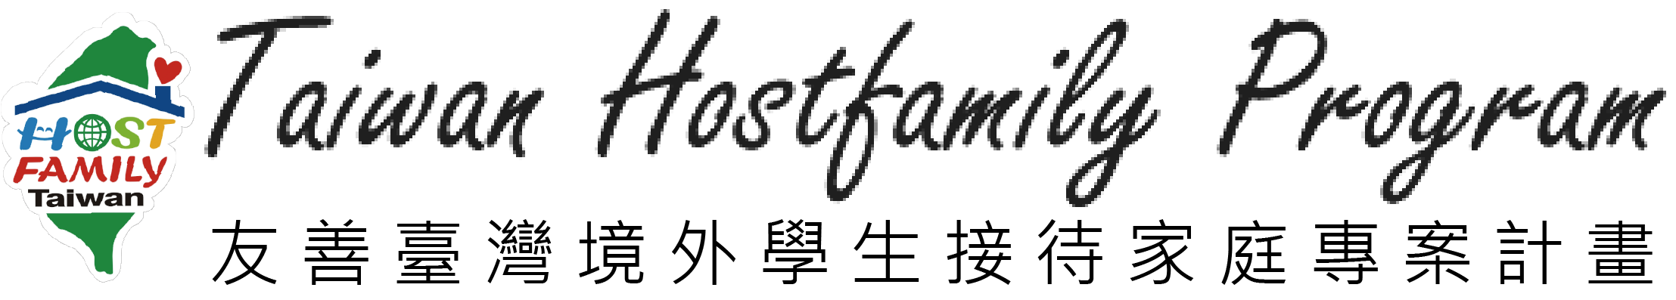
2017 Community Cultural Activity in Taichung
- Meeting point: Former Taichung Railway Station, Front Exit
(Between to 7-11 and Information Center)
舊臺中火車站前站 (7-11與臺中火車站旅遊服務中心中間)
- Date: November 4th (Sat.), 2017
- Location: Toubien Community, Taichung (台中市頭汴社區)
- Participant:
(1) Host family (2) International students study in Taiwanese universities
- Fee: Free! The transportation from your living place to the meeting point is your responsibility.
- Sign up: Please sign up online. http://www.hostfamily.org.tw/en/news/85-13610
- Deadline: October 23th, 2017
- Contact Information:
Taiwan Hostfamily Program
許郁屏 Gianna Hsu
◎TEL: 06-2533131 #1603 ◎E-MAIL: hostfamily@stust.edu.tw
- Notes: (1) Please bring your water bottle, rain gear and sun care products.
(2) Remember to wear comfortable, casual clothes and shoes.
Time | Content of Activity
10:00 | Gathering at Former Taichung Railway Station, Front Exit  (舊臺中火車站前站)
10:20-10:30 | Meet & Greet
10:30-11:00 | Leave for Toubien Community
11:00-12:00 | Guided Tour and Taiwanese earth oven experience－Build
12:00-14:00 | Lunch－Barbecue (We also provide vegetarian barbecue.)
14:00-16:00 | Taiwanese earth oven experience－Put food in the oven  Free time－You can challenge the rock climbing, large pinball and some exciting facilities here. Or, take a stroll to enjoy the beauty of nature.
16:00-16:30 | Taiwanese earth oven experience－Enjoy the snack!
16:30- | Leave for Former Taichung Railway Station

Sponsor: Ministry of Education (R.O.C)
Organizer: Southern Taiwan University of Science and Technology

